**conditional formatting** :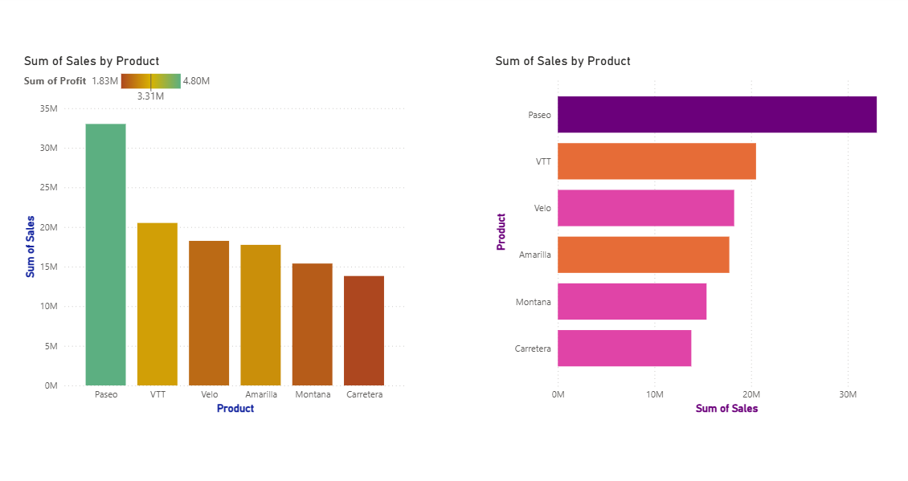

**CT :** Stacked Column chart and Bar chart

**X-Axis :** Product , Sum of sales

**Y-Axis :** Sum of sales , Products

**Insights :**  Both charts represent the Sum of sales by product.

**Paseo** stands out as the top-performing product, with sales exceeding **33M**, making it the clear leader in revenue.

while Montana and Carretera underperform both in sales and profit.

**Filter :** by using filter.

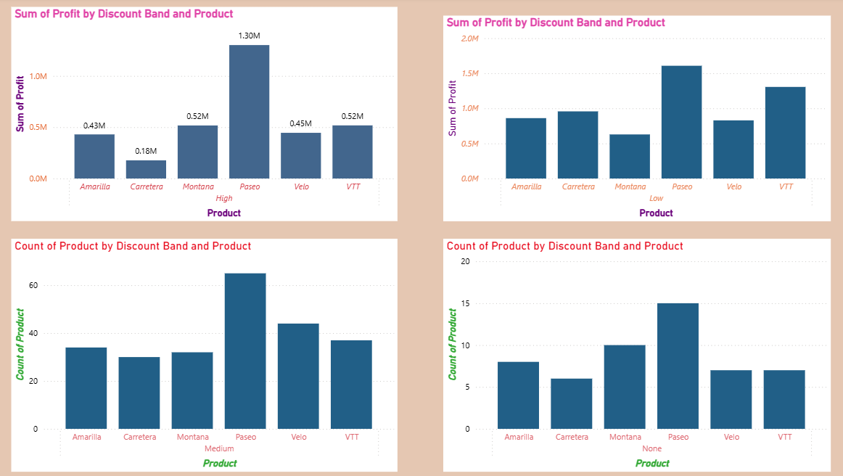

**CT :** Stacked Column chart

**X-Axis :** Product(top chat) , Product(for bottom chat).

**Y-Axis :** Sum of profit(top chat), Count of products(for bottom chat).

**Top Two Charts (Profit by Discount Band and Product):**

* Paseo has the highest profit in both High and Low discount bands.
* VTT performs well under Low discount, while Carretera has the lowest profit in High discount.
* Profit levels vary strongly across discount bands.

**Bottom Two Charts (Count of Product by Discount Band and Product):**

* Paseo has the highest product countin Medium and None discount bands.
* Other products like Amarilla, Velo, and Montana have moderate counts, while Carretera is on the lower side.
* Most product counts fall in the Medium discount band, while the None band has fewer counts overall.